PROJECT REPORT TEMPLATE

**Vehicle Management System**

**1. Introduction**

* 1. **Overview**

Vehicle Management is an application where a customer Details are stored in order to choose Cars, bikes and commercial vehicles for travel with in the city. The data which is stored here is further used to remind them if any offers are provided during the seasons and any updates regarding are sent to them in the form of messages and mails.

* 1. **Purpose the use of this project**

A vehicle management system is a software system or platform that serves to manage commercial fleets of vehicles, such as cars, vans or trucks or even heavy equipment to ensure they’re utilized safely, efficiently and professionally, while making sure they’re well maintained and high performing.

**2. Problem definition & Design Thinking**

**2.1 Empathy map**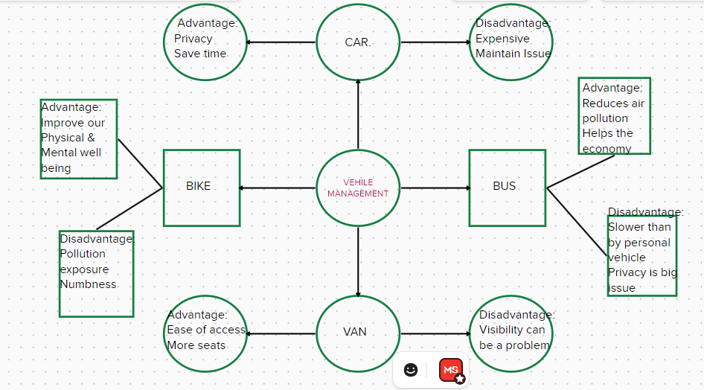*(Fig.1)*

2.2 **Ideation & Brainstorming Map**

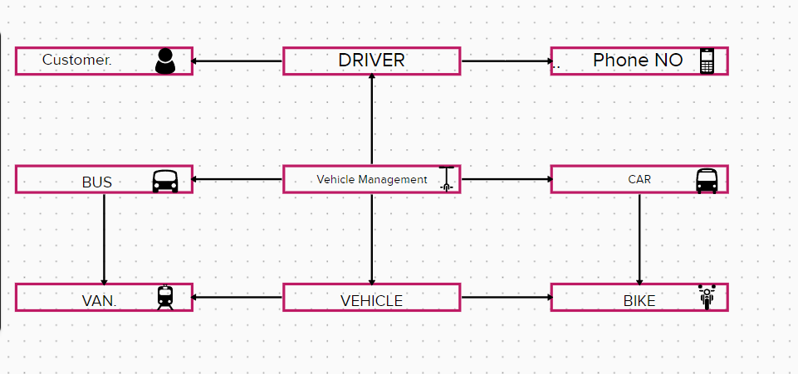

*(Fig.2)*

**3.** **Result**

**3.1 Data model**

|  |  |  |
| --- | --- | --- |
| **S.NO** | **OBJECT** | **OBJECT FIELD TYPE** |
| **1** | **Vehicle** | **Text** |
|  | |  |  |  | | --- | --- | --- | | **Field** | **Field Name** | **Field Type** | | Field 1 | Customer name | Text | | Field 2 | Customer Mobile Number | Number | | Field 3 | Vehicle Type  2 wheeler  4 wheeler | Pick list | | Field 4 | 2Wheelers  Hero  Honda  Bajaj  Tvs  Ola | Pick list | | Field 5 | 4 wheelers  Mahindra  Benz  Audi  Volvo | Pick list | | Field 6 | Vehicle Name | Text | | Field 7 | Vehicle No | Number | | Field 8 | Classic No | Number | | Field 9 | Colour | Text | | Field 10 | Body Type | Text | |  |
| **2** | **Driver** | **Text** |
|  | |  |  |  | | --- | --- | --- | | **Field** | **Field Name** | **Field Type** | | Field 1 | Driver Name | Text | | Field 2 | Licence No | Text | | Field 3 | Mobile No | Number | | Field 4 | Fair Per Hour | Text | | Field 5 | Age | Number | | Field 6 | Experience | Number | | Field 7 | Religion | Text | | Field 8 | Language | Pick list | | Field 9 | Driving Work | Pick list | |  |

*(Table.1)*

**3.2 Activity & Screenshot**

* + - Go to Google- Search- Salesforce Developer Login.
    - Click- Salesforce Login.
    - Type- Email ID & Password- Enter.
    - Click- Setup.
    - Go to App Launcher- Type- Vehicle Management- click.
    - Our project is shown.

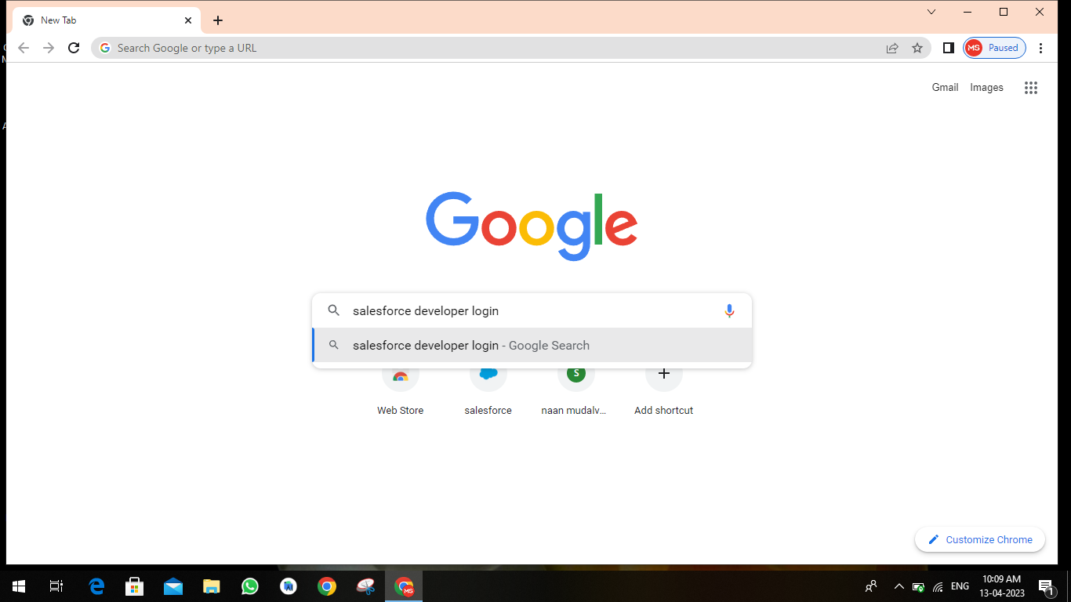

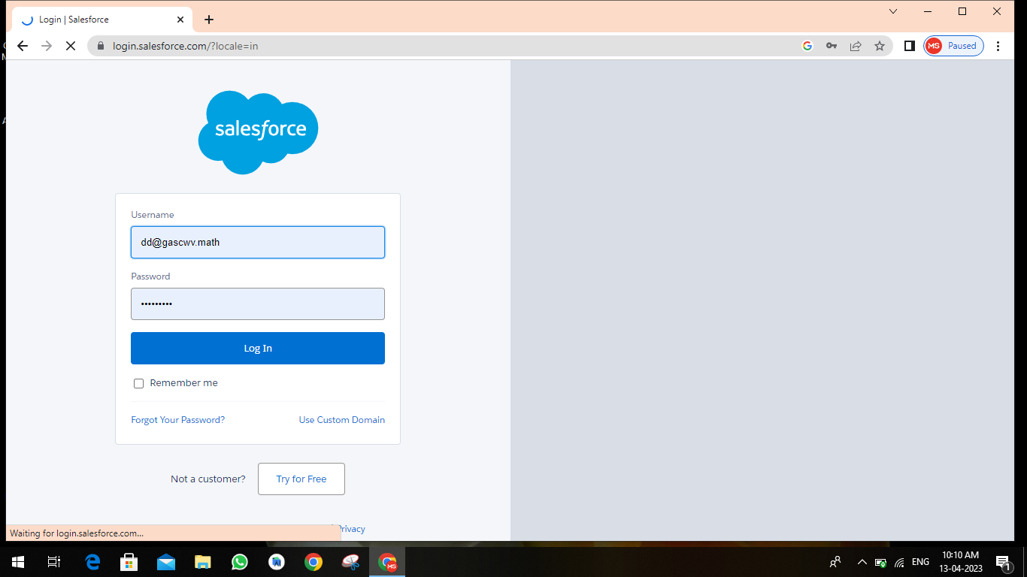

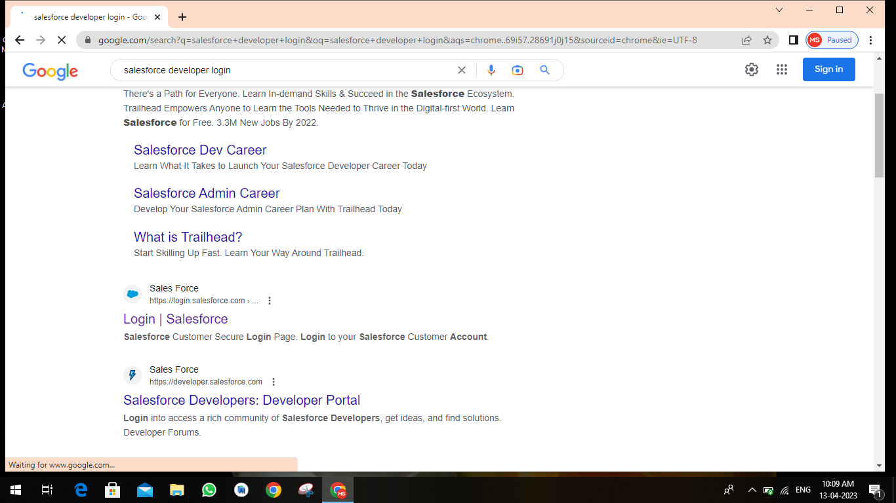

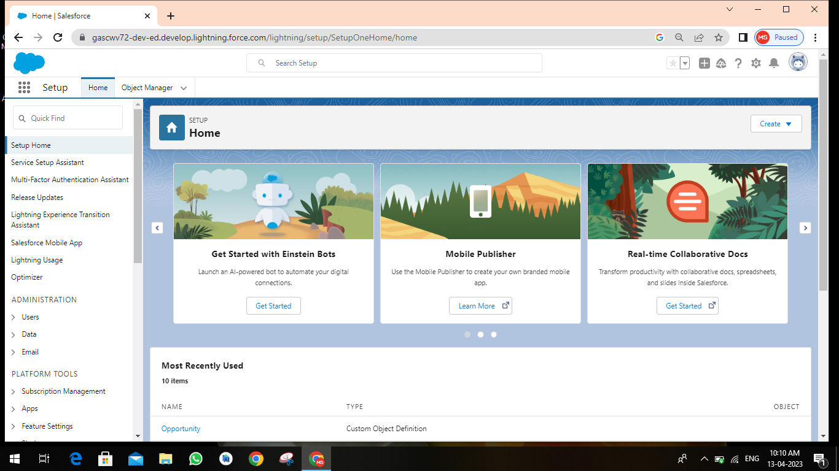

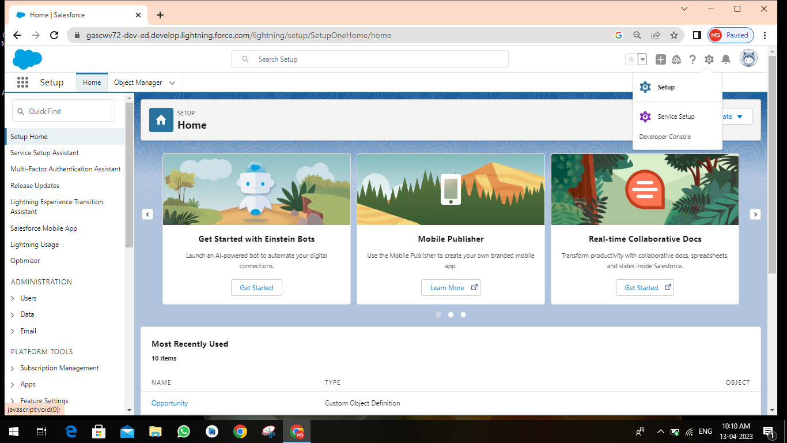

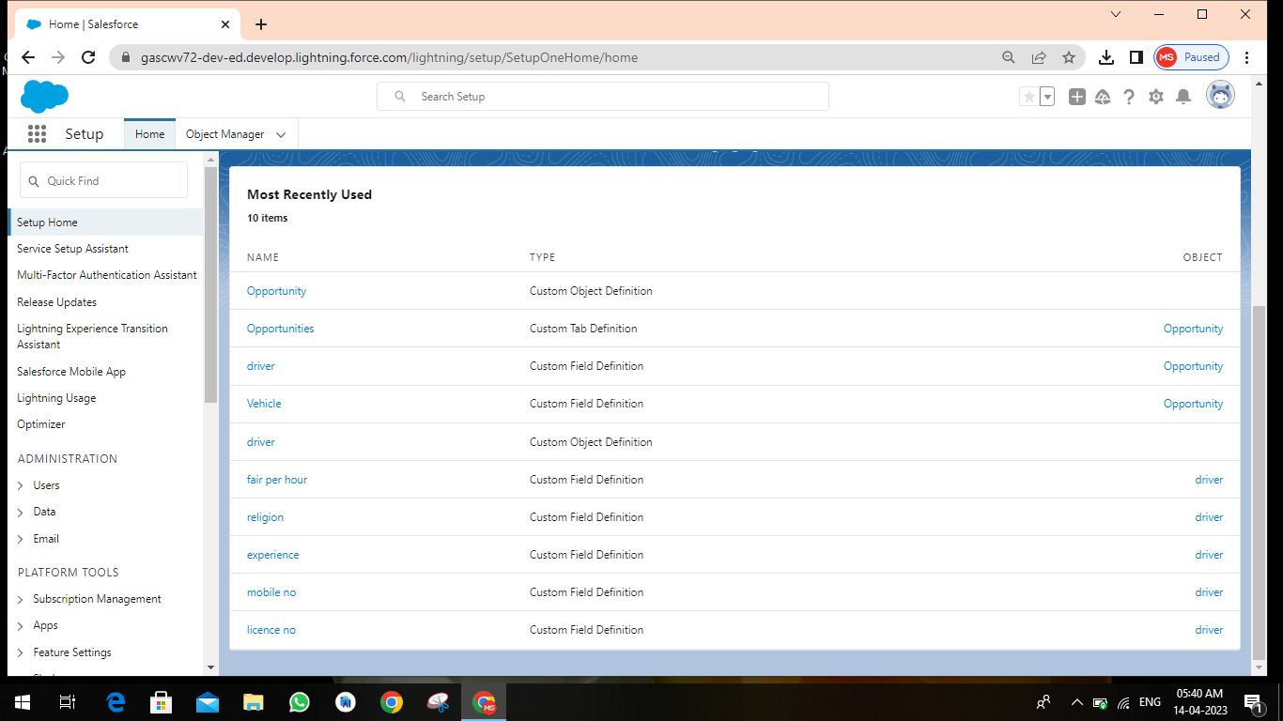

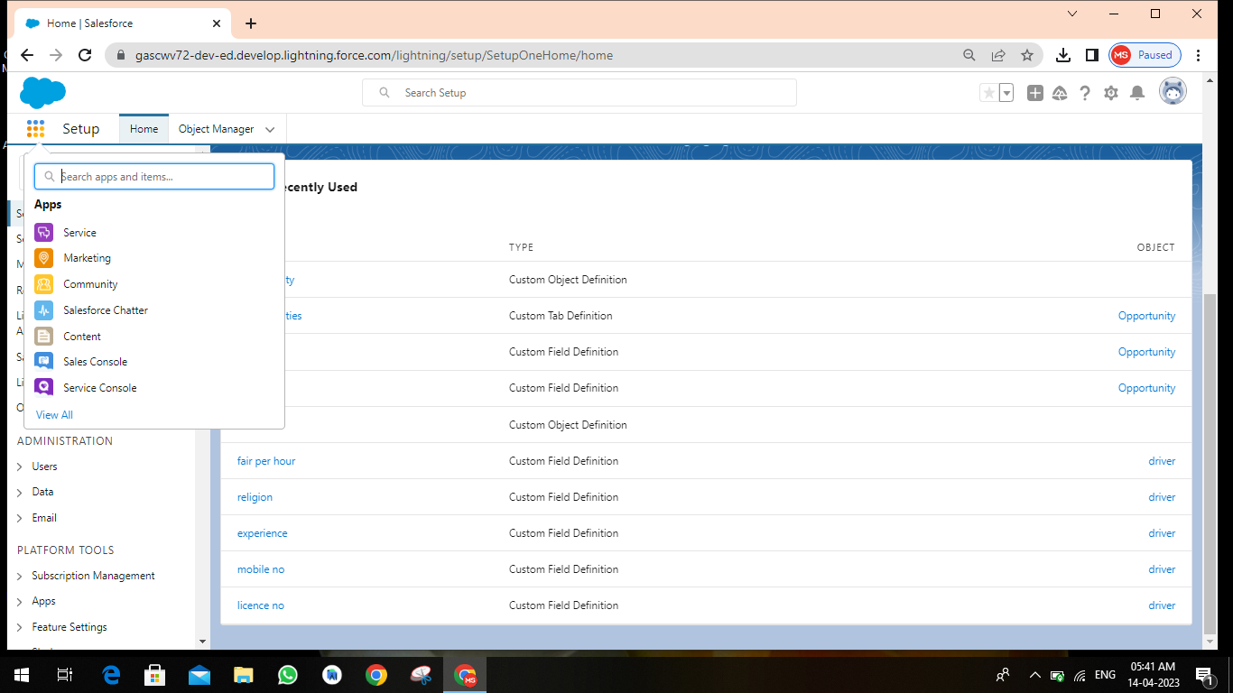

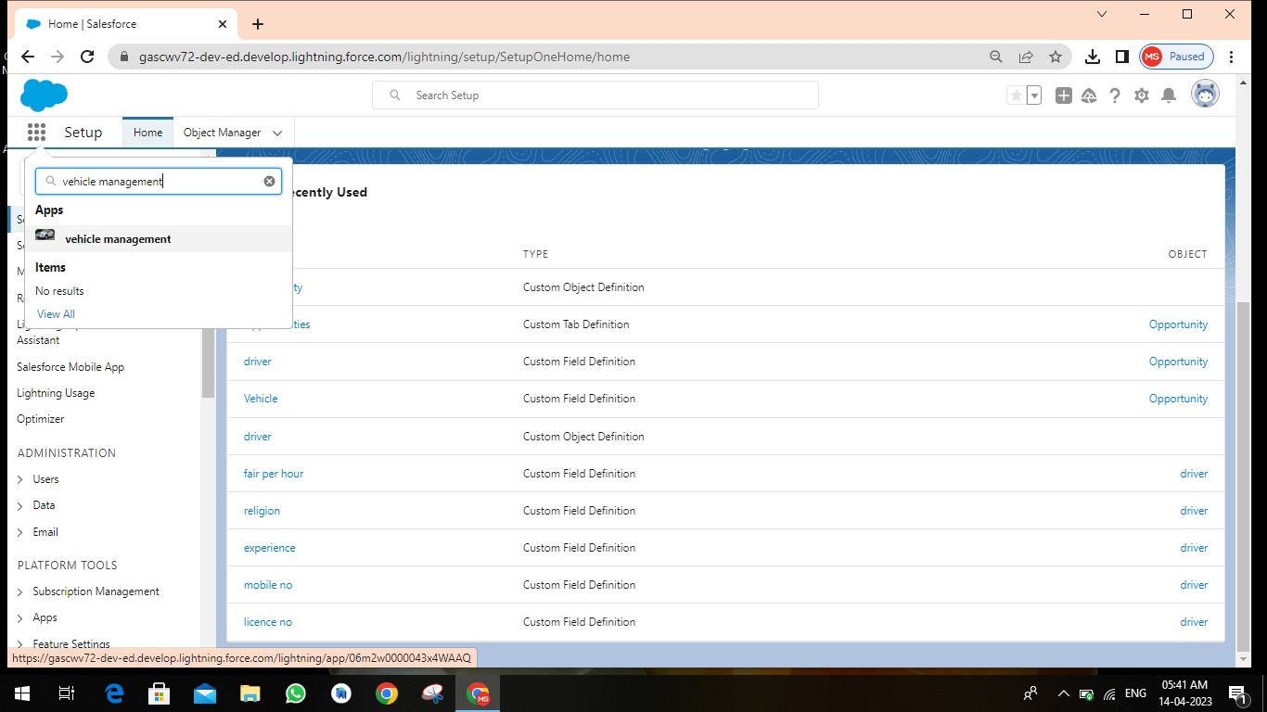

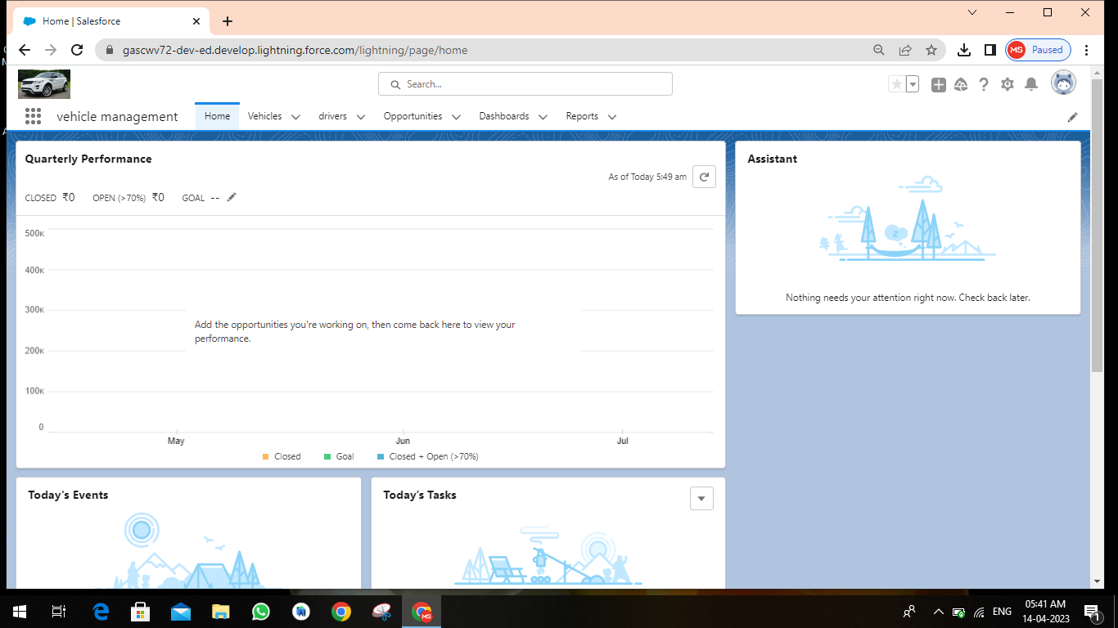

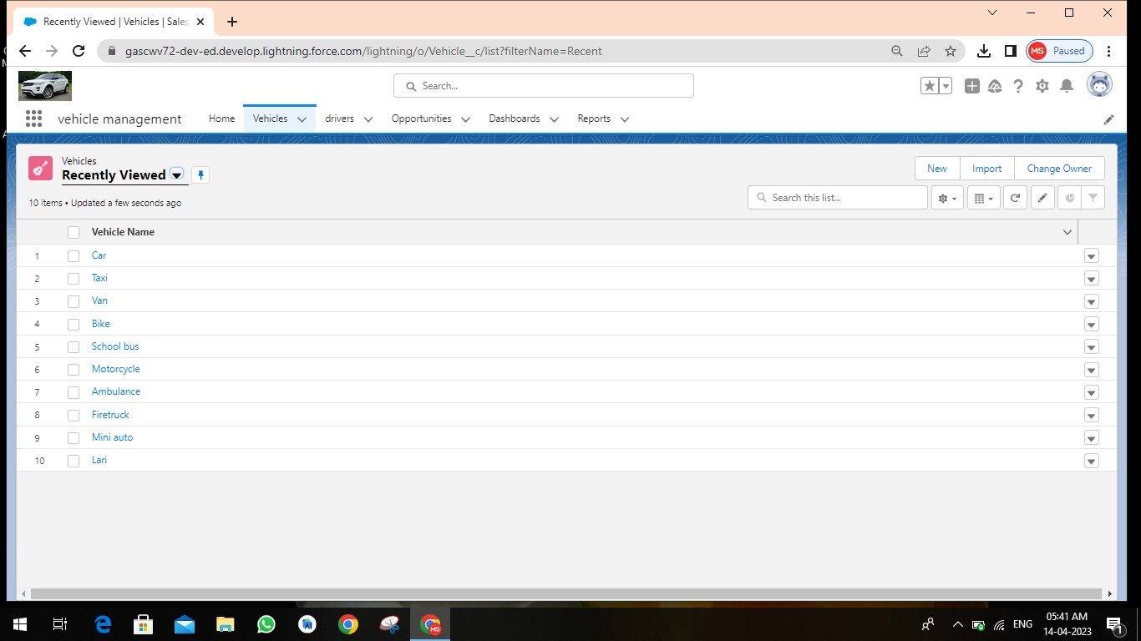

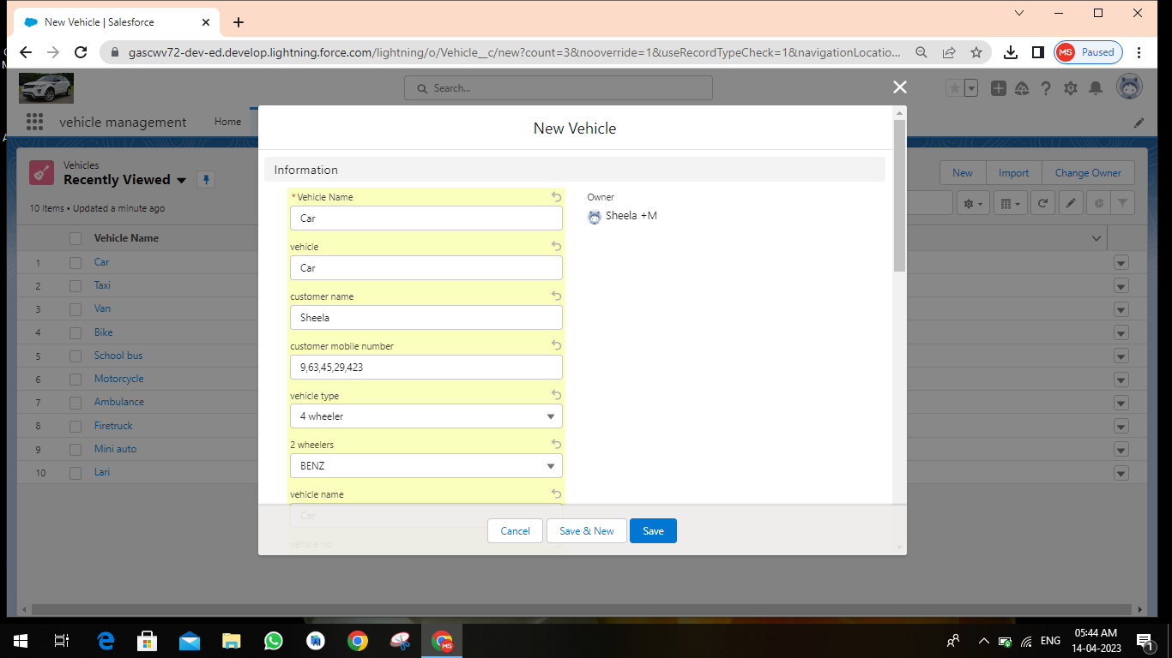

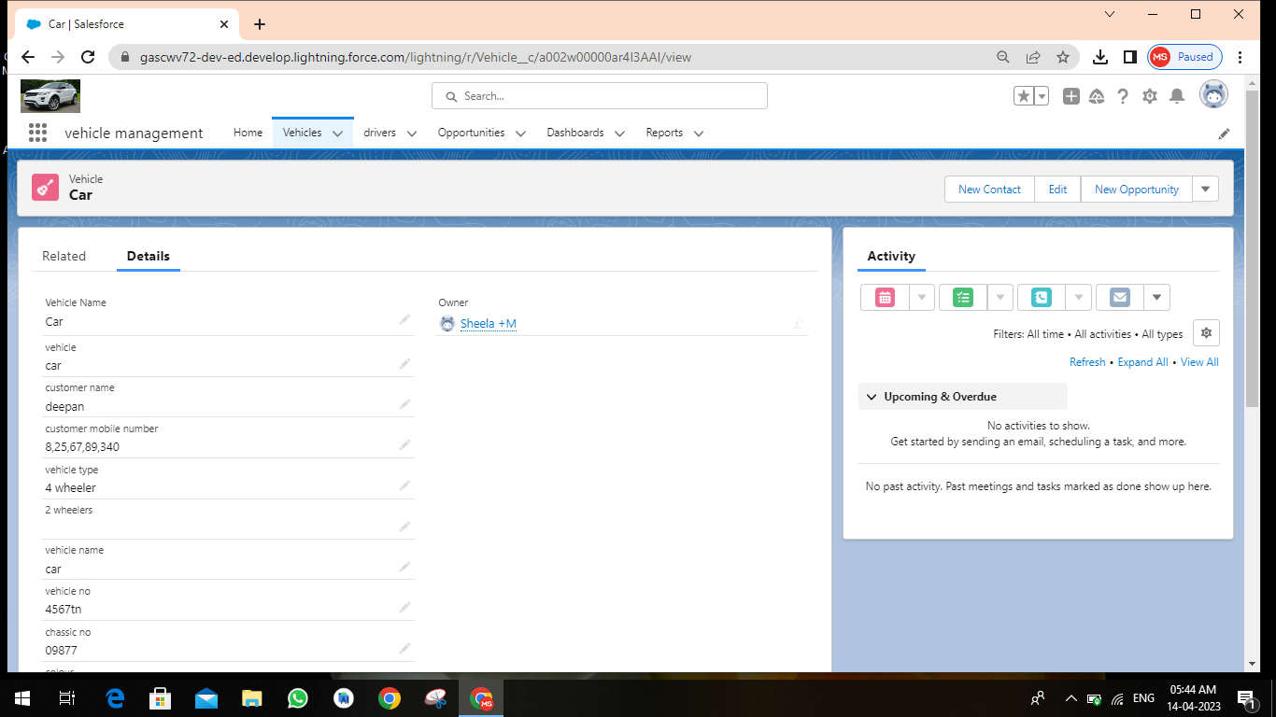

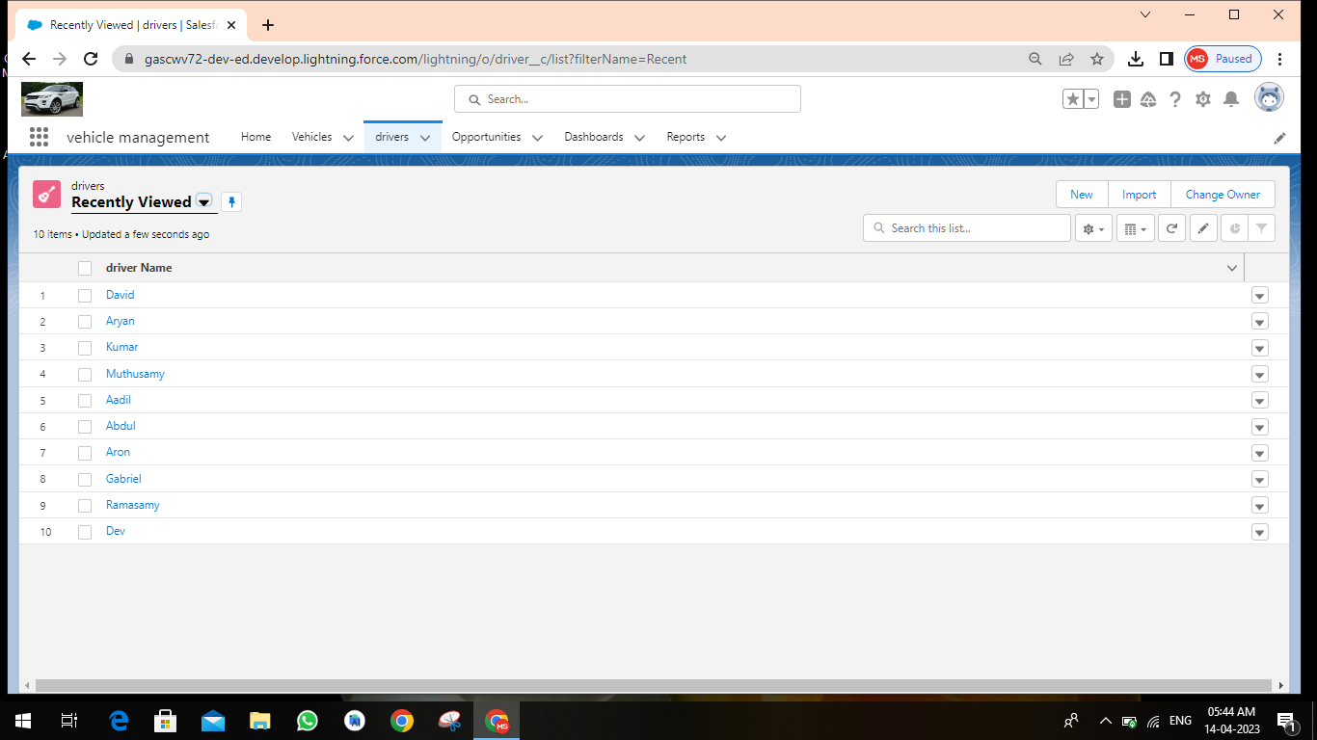

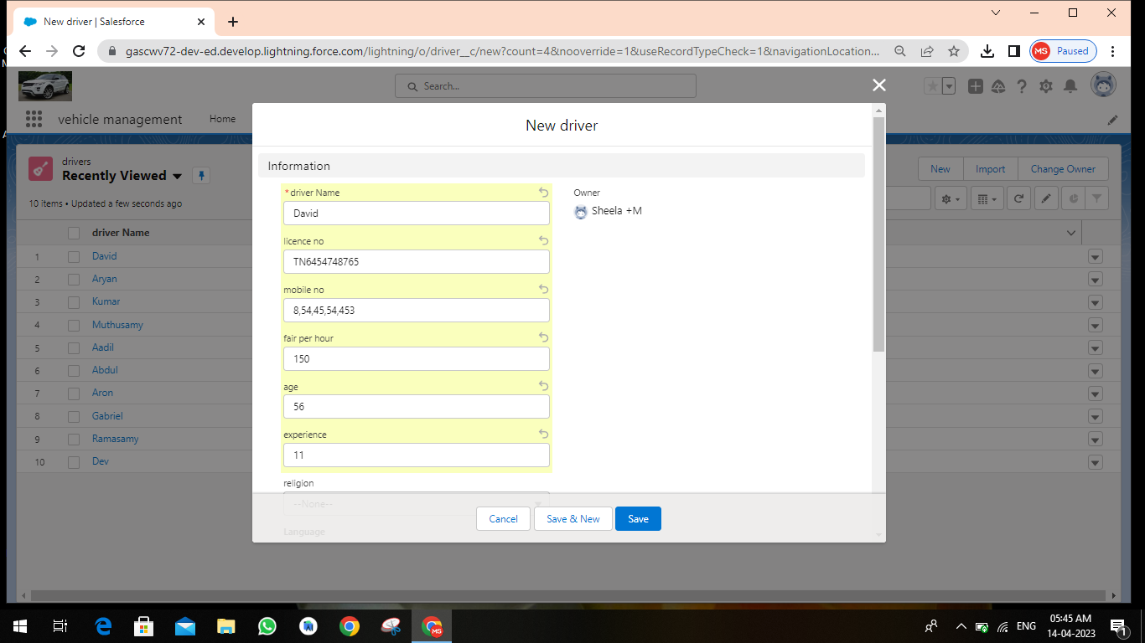

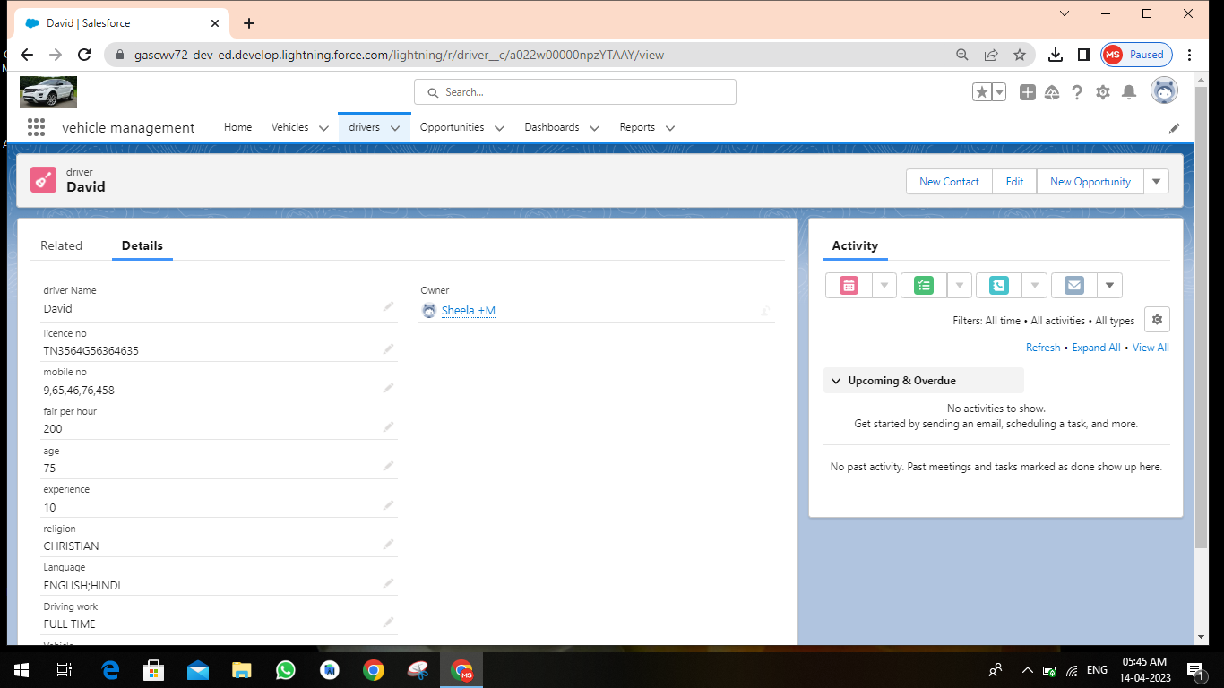

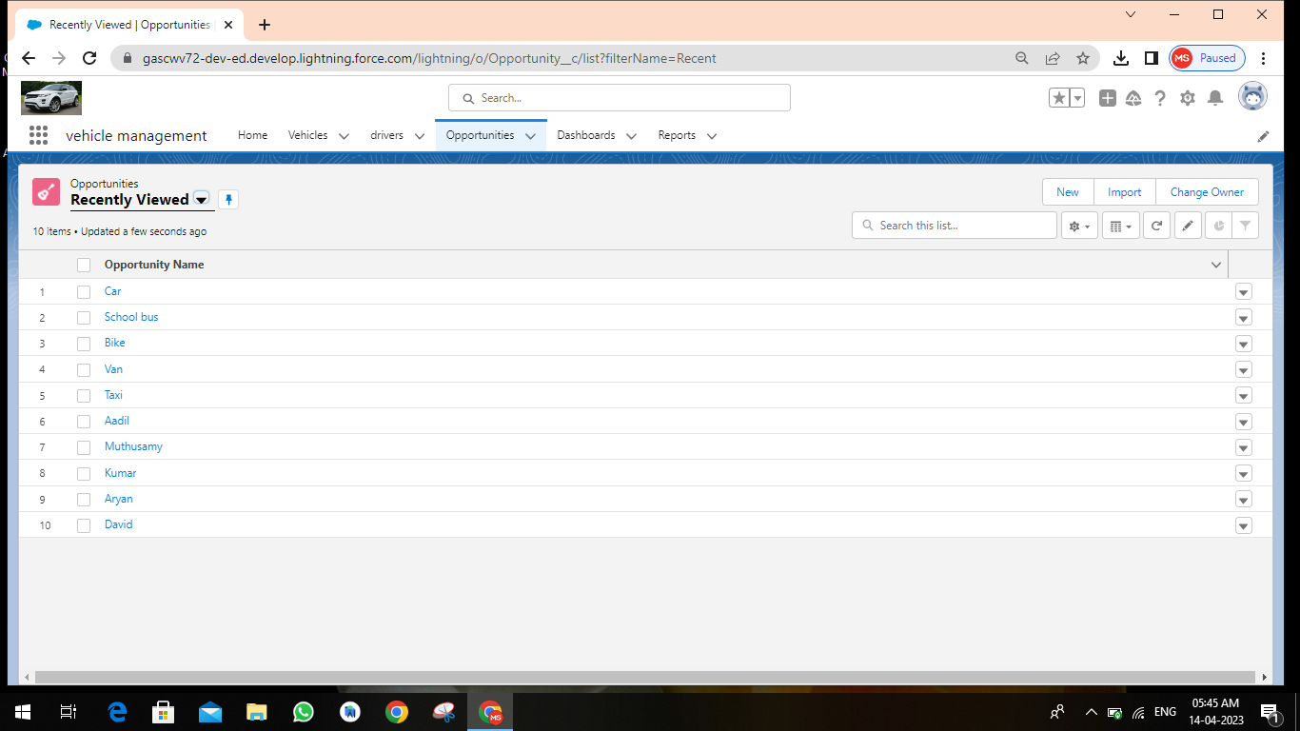

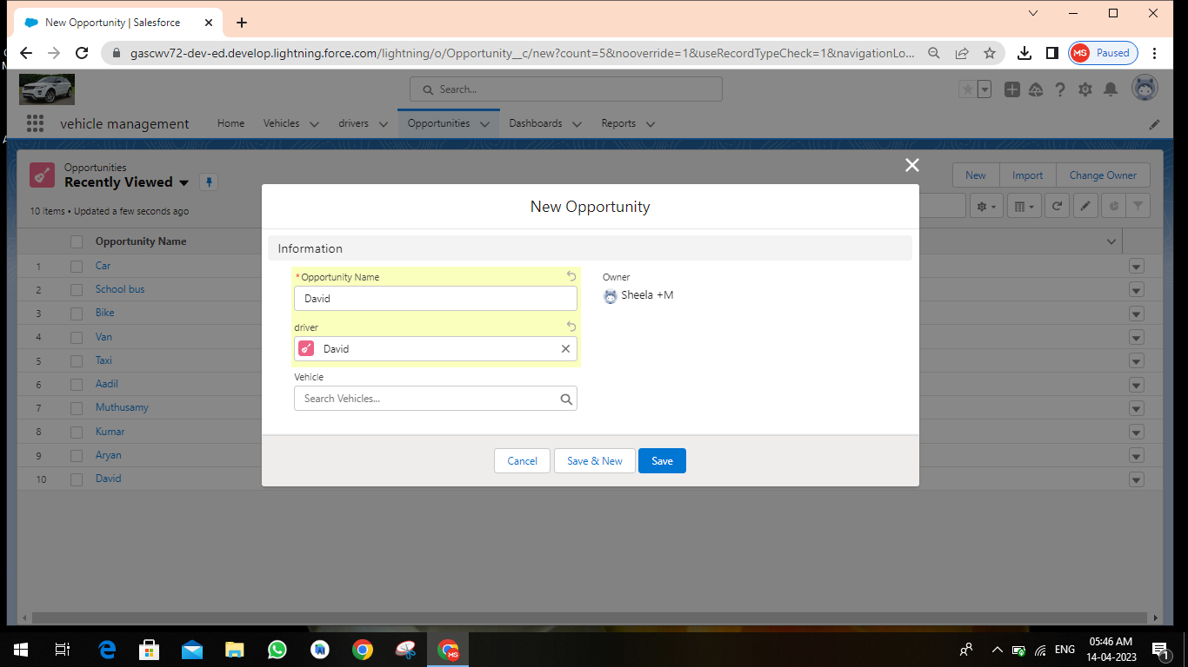

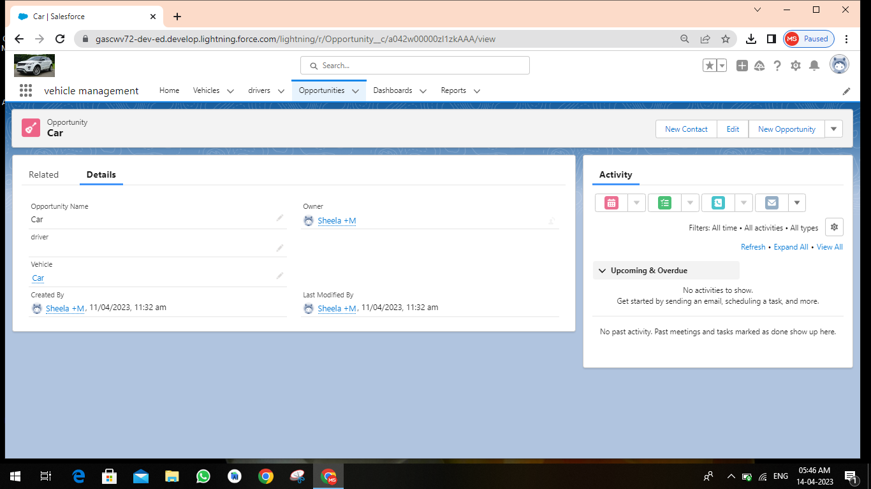

**4. Trailhead Profile Public URL**

Team Lead : <https://trailblazer.me/id/sheem16>

Member 1 : https://trailblazer.me/id/umaktb9

Member 2 : https://trailblazer.me/id/uusha7

Member 3 : https://trailblazer.me/id/valap18

Member 4 : https://trailblazer.me/idsnehp17

**5. Advantages & Disadvantages**

* Duplication of the vehicle data is avoided.
* As vehicle number is already stored in the master therefore human mistakes can be avoided.
* Timely alerts ensure that penalties are avoided.
* It is a difficult to manage and maintain vehicle management.

**6. Applications**

**Admin**

* + - View/Edit/Delete Vehicle Details
    - View/Edit/Delete Driver Details
    - Booking Status Details

**User Module**

* + - Login/Registration of User
    - Take a Car trip (Google Map Integration)
    - View Car Details
    - Car Booking

**7. Conclusion**

Our project is only a humble venture to satisfy the needs in the library. Several user friendly coding have also adopted. This package shall prove to be a powerful package in satisfying all the requirements of the organization. The objective of software planning is to provide a frame work that enables the manger to make reasonable estimates made within a limited time frame at the beginning of the software project and should be updated regularly as the project progresses. Last but not least it is no the work that played the ways to success but ALMIGHTY.

**8. Future Scope**

* + - To register and keep the information about all vehicles.
    - To build up a system that provides and generates the summary.
    - Report from the database records in order to get the whole view about the vehicles amount.
    - Summarize the accidental records and responds for the further improvements.
    - A web based tool where user can search for additional information of the vehicle.

**THANK YOU**

Team Lead : M. Sheela

Member 1 : K. Uma

Member 2 : B. Usha

Member 3 : P. Valarmathi

Member 4 : P. Sneha

B.sc mathematics

Government Arts and Science College for women, Veppur 621 717.